
"Industry 4.0 a baseline Survey among MSMEs"
UTTAR PRADESH CURRENT AFFAIRS
07th June 2024
- The Department of Telecommunications has announced plans to launch a new initiative aimed at assisting organisations and startups through the adoption of emerging technologies for the industry.
- It has called for proposals for an "Industry 4.0 Baseline Survey" among MSMEs that aligns with the broader vision of driving digital transformation and preparing industries for the advent of 5G and 6G technologies.
- The survey will cover five regions each in the northern and southern parts of India over a period of 60 days.
Target:
- The survey aims to understand the challenges faced by MSMEs in adopting Industry 4.0 and utilising advanced technologies.
- The survey aims to lay the foundation for a strong eco-system capable of leveraging the capabilities offered by AI, IoT, cloud computing and integration of 5G and 6G networks.
- It will also include identifying sector-specific needs and priorities in at least 10 areas, identifying the diverse landscape of MSMEs and providing targeted support to foster innovation and competitiveness.

Person In News
Sunita Williams | - Indian-origin astronaut Sunita Williams of the US space agency NASA has become the first woman to fly into space on a Boeing Starliner in the first crew mission. Her partner Butch Wilmore was also with her in this mission.  - 59-year-old Sunita Williams has created history by becoming the first woman to fly on the first mission of a new human-rated spacecraft.  - This flight was launched on a United Launch Alliance Atlas V rocket from Space Launch Complex-41 at Cape Canaveral Space Force Station in Florida. | 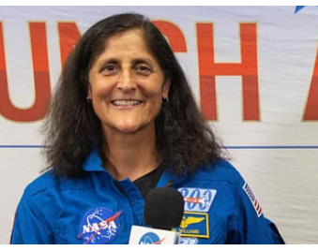
Helen Mary Roberts | - She became the first woman from Christian and minority community to be promoted to the rank of Brigadier in the Pakistan Army Medical Corps. | 

Important News- Worldwide
Sweden | - Swedish automaker Volvo Cars will launch the world's first EV battery passport, recording the origin of raw materials, components, recycled content and carbon footprint for its flagship EX90 SUV.  - Volvo will issue the passport in line with EU rules.  - Battery passports will become mandatory for electric vehicles (EVs) sold in the EU from February 2027, showing information including the composition of the battery, the origin of key materials, their carbon footprint and recycled content.  - The EV battery passport is the result of a collaboration between Volvo and UK-based startup Circular, which uses blockchain technology to map supply chains for companies. | 
Indonesia | - Indonesia's Mount Ibu volcano erupted twice in the same day, spewing bright red lava and rocks into the night sky and producing a display of volcanic lightning.  - The 1,325-metre-high volcano on the eastern island of Halmahera erupted twice, according to volcanology agency PVMBG.  - The first explosion occurred at 1:30 a.m. local time, spewing glowing lava and rocks accompanied by lightning.  - The second explosion occurred at 7:46 a.m. for two minutes, spewing volcanic ash as high as 1,200 meters. | 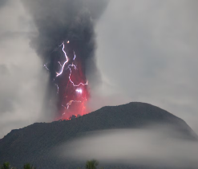
Netherlands | - According to Commerce Ministry data, the Netherlands has emerged as India's third largest export destination after the US and the UAE during 2023-24.  - The main commodities that recorded good growth in exports to the Netherlands last fiscal include petroleum products ($14.29 billion), electrical goods, chemicals and pharmaceuticals. | 

State News
Karnataka, Dharwad | - A team of teachers and students of Indian Institute of Technology (IIT) Dharwad developed a fire rescue assistive drone.  - Professor Sudhir Siddhapureddy and Professor Ameer Mulla led the team, with funding from TiHAN Foundation, IIT Hyderabad (NMICPS, Government of India). | 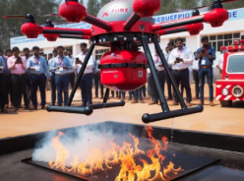

Important Days/Dates
6th June | World Pest Day  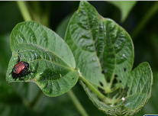 | - World Pest Day is observed every year on 6 June to raise awareness about pest management for health and food safety.  - It aims to bring together pest management organisations from around the world to raise awareness about the industry's impact.  - Insects are one of the most diverse organisms on Earth. There are more than one million species of insects. Despite being an important part of nature, insects also cause damage to crops, which can pose a threat to food security and humans.

Awards
UN WSIS 2024 Prize | - Centre for Development of Telematics (C-DOT), the premier telecom R&D centre of Government of India, has been awarded the United Nations WSIS 2024 “Champion” award for the project “Mobile-enabled Disaster Resilience through Cell Broadcast Emergency Alerting”.  - It is recognized under AI, C-7, e-Environment in the category of ‘Benefits in all aspects of life – e-Environment’.  - C-DOT’s Mobile-enabled Cell Broadcast Emergency Alerting platform is an end-to-end solution for near real-time delivery of life-saving emergency information to mobile phones via cellular networks.
Hindi Sahitya Bharati Award | - Krishn Prakash, famous as the head of Mumbai Police's anti-terrorism unit Force One, has been awarded the Hindi Sahitya Bharati Award.  - This award was given during the Sab Mein Ram Shashwat Shri Ram Multicultural Festival held in Mumbai. | 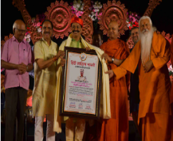
The Gudleppa Hallikeri Award | - Poet and playwright Siddhalinga Pattanashetti has been selected for the prestigious Gudleppa Hallikeri Award for 2024 by the Gudleppa Hallikeri Memorial Foundation, Hosaritti (Haveri district).  - The Gudleppa Hallikeri Award is given to individuals who have made significant contributions to literature, society or social service. | 

Short News
- Recently, Prime Minister Shri Narendra Modi launched the campaign 'Ek Ped Maa Ke Naam' on the occasion of World Environment Day.
- The Prime Minister also urged all countrymen to contribute to making our planet better by planting a Peepal tree in Delhi's Buddha Jayanti Park and said that this is a great effort for our efforts towards sustainable development.



PW Web/App: https://smart.link/7wwosivoicgd4

